Disposition: Resolved
OMG Issue No: 12561
Title: Section: Annex D.2 (Probability Distributions)
Source:
ESI (Adrian Noguero, adrian.noguero@esi.es)
Summary:
We have found that the current format for modelling probability distributions is not very good is some cases. For example, it is hard to model correctly the probability distribution related to a SporadicPattern. We propose that distributions are modelled as a ProbabilityDistribution <<choice_type>> element, with each probability distribution modelled as a <<tuple_type>> element each with the parameters needed (e.g. Uniform <<tuple_type>> should have 2 parameters: a min:NFP_Real and max:NFP_Real).

Resolution:

There is a misunderstanding in the way MARTE deals with probability distribution expressions. This is, in any case, a weak aspect in the description of such specification mechanism in MARTE. This resolution proposes to clarify this aspect, by adding an example in the NFP chapter and by making explicit the list of distributions in Annex D.

In addition, this issue proposes to complete the textual description of all the NfpTypes included in the library MARTE_NfpTypes.

Issue Dependency Warning: Note that the texts and figures provided in this issue depend on Issue 12196, which proposes new probability distributions. Thus, if Issue 12196 is not accepted, these new probability distributions need to be removed from the texts and figures proposed in this issue.

Revised Text:
We propose additions in four distinct parts:
(1) In Annex D, add a new Figure D.6 directly under Figure D.5 and before the section D2.2.
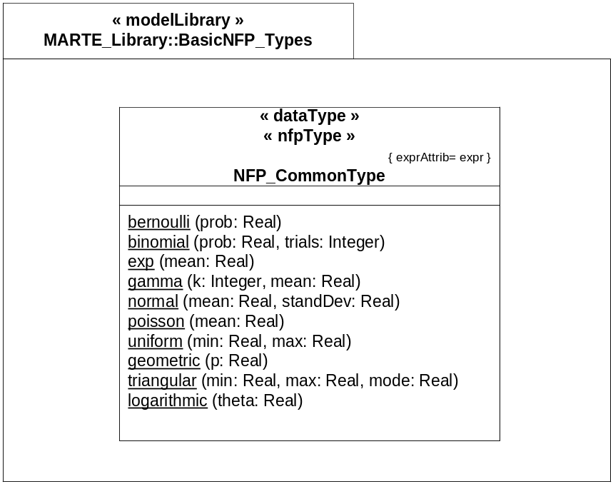
Figure D.6 – Extract of the MARTE pre-declared NFP types: Operations in NFP_CommonType

(1') Add following text before the figure:
Figure D.6 describes the set of operations in NFP_CommonType that declare common probability distributions. Note that it represents a partial view of NFP_CommonType. The properties of this NfpType are described in Figure D.5.

(2) In Annex D, update the description of the following specific NfpTypes (and shift the numbers of the remaining DataType descriptions):

D.2.2 NFP_CommonType
This is the parent NfpType that contains common parameters (modeled as UML Properties) and common operations of the various NfpTypes defined in MARTE.
Attributes
- expr: VSL_Expression [0..1] Attribute representing an expression. MARTE uses the VSL language to define expressions.
- source: SourceKind [0..1] Peculiarity of NFPs associated with the origin of specifications. Predefined kind of sources for values are estimated, calculated, required and measured.
- statQ: StatisticaQualifierKind [0..1] Statistical qualifier indicates the type of “statistical” measure of a given property (e.g., maximum, minimum, mean, percentile, distribution).
- dir: DirectionKind [0..1] Direction attribute (i.e., increasing or decreasing) defines the type of the quality order relation in the allowed value domain of NFPs. Indeed, this allows multiple instances of NFP values to be compared with the relation “higher-quality-than” in order to identify what value represents the higher quality or importance.
Operations
- bernoulli (prob: Real) Bernoulli distribution has one parameter, a probability (a real value no greater than 1).
- binomial (prob: Real, trials: Integer) Binomial distribution has two parameters: a probability and the number of trials (a positive integer).
- exp (mean: Real) Exponential distribution has one parameter, the mean value.
- gamma (k: Integer, mean: Real) Gamma distribution has two parameters (“k” a positive integer and the “mean”).
- normal (mean: Real, standDev: Real) Normal (Gauss) distribution has a mean value and a standard deviation value (greater than 0).
- poisson (mean: Real) Poisson distribution has a mean value.
- uniform (min: Real, max: Real) Uniform distribution has two parameters designating the start and end of the sampling interval:
- geometric (p: Real) The Geometric distribution is a discrete distribution bounded at 0 and unbounded on the high side.
- triangular (min: Real, max: Real, mode: Real) The Triangular distribution is often used when no or little data is available; it is rarely an accurate representation of a data set.
- logarithmic (theta: Real) The Logarithmic distribution is a discrete distribution bounded by [1,...]. Theta is related to the sample size and the mean.
D.2.3 NFP_Boolean, NFP_Natural, NFP_String, NFP_Real, NFP_Integer, NFP_DateTime
Generalizations
- NFP_CommonType.
Attributes
- value: {MARTE_PrimitiveTypes::Boolean, UnlimitedNatural, String, Real, Integer, DateTime} [0..1] Attribute representing the value part of a NfpType.
D.2.4 NFP_DataTxRate, NFP_Frequency, NFP_Length, NFP_Area, NFP_Power, NFP_DataSize, NFP_Energy, NFP_Weight
Generalizations
- NFP_Real.
Attributes
- unit: {MeasurementUnits:: DataTxRateUnitKind, FrequencyUnitKind, LengthUnitKind, AreaUnitKind, PowerUnitKind, DataSizeUnitKind, EnergyUnitKind, WeightUnitKind} [0..1] Attribute representing the measurement unit.
- precision: Real [0..1] Degree of refinement in the performance of a measurement operation, or the degree of perfection in the instruments and methods used to obtain a result. Precision is characterized in terms of a Real value, which is the standard deviation of the measurement.
D.2.5 NFP_Duration
Generalizations
- NFP_Real.
Attributes
- unit: MeasurementUnits:: DurationUnitKind [0..1] Attribute representing the measurement unit.
- clock: String [0..1] Attribute representing the reference to a clock.
- precision: Real [0..1] Degree of refinement in the performance of a measurement operation, or the degree of perfection in the instruments and methods used to obtain a result. Precision is characterized in terms of a Real value, which is the standard deviation of the measurement.
- worst: Real [0..1] Attribute representing the worst-case value of a duration.
- best: Real [0..1] Attribute representing the best-case value of a duration.
D.2.6 FP_Percentage
Generalizations
- NFP_Real.
Attributes
- unit: String= “%” [0..1] Attribute representing the measurement unit.
D.2.7 NFP_Price
Generalizations
- NFP_Real.
Attributes
- unit: String= “$US” [0..1] Attribute representing the measurement unit.

(3) In the NFP chapter, Section 8.3.4.1, page 45, first paragraph replace:
The old text:
“Additionally, although not shown in Figure 8.6, we include a set of probability distribution operations that can apply to the pre-declared NFP Types.”
By the new text:
“The NFP_CommonType (parent of all the other NfpTypes) includes a set of probability distribution operations that are defined in Annex D, Section D.2.2 (NFP_CommonType). This list of probability distributions is certainly not exhaustive but it includes the more common distributions used in state-of-the-art performance analysis and simulation tools. Further probability distributions can be added in specialized libraries without needing any modification in the MARTE profile or VSL.”

(4) In the NFP chapter, Section 8.3.4.1, page 45, after the list of probability distributions, add the following example:
For example, consider a property typed by NFP_CommonType:
distribution: NFP_CommonType
The values of this property can be constructed by using a special VSL expression called CallOperationExpression (see the VSL annex, package Expressions, for further details). For instance, the following expression:
distribution= normal (50, 7)
is a CallOperationExpression that calls the probability distribution operation “normal” of the defining NfpType (NFP_CommonType) and provides the arguments for its parameters “mean: Real” and “standDev: Real”.

Disposition: Resolved

